ETL PROJECT Technical report

A look at Farmers Market locations and the surrounding population

|  |  |
| --- | --- |
| Prepared By: | Sanita Gurung  Laci Her  Travis Tharp |
| Date: | April 15, 2020 |
| Organization: | KU Data Analytics Boot Camp |

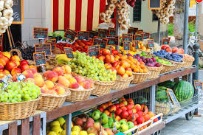

Executive Summary

With a trend for consumers to purchase locally sourced and organic food, farmers markets have gained popularity in recent years. This project paired a list of farmers markets around the country, with the local population. This data could be used for highlighting areas that may have a potential need for a local farmers market.

Project Objectives

The objective of the project was to provide a collaborative report based upon the farmers market locations and population centers. This data could help identify areas that are not currently served by a local farmers market.

Methodology

The US Department of Agriculture publishes a list of all registered farmers markets. This data includes the market’s name, address, latitude and longitude.

To incorporate a population for each city with a farmer’s market, we used the US Census Bureau’s estimated population data for 2018.

Both datasets were available as csv tables. After importing each table into Pandas as a DataFrame, we removed un-needed columns and renamed the remaining columns to be formatted similarly between the datasets.

We then used PGAdmin to create tables for each set of data and created a connection engine between the Jupyter Notebook and PGAdmin. Once the data was imported to the tables, we used a JOIN function to combine the tables on city and state. This gave us our final dataset.

References

US Department of Agriculture dataset of all registered farmers markets:

<https://catalog.data.gov/dataset/farmers-markets-directory-and-geographic-data>

US Census population data

<https://www.census.gov/data/tables/time-series/demo/popest/2010s-total-cities-and-towns.html>